Test Case: tc002_SPX_Dev5_Crear_Requisicion_Spot_Tipo_Cobro_Project
Step 1 - Enter username and password and click to button Enter: Credentials Entered
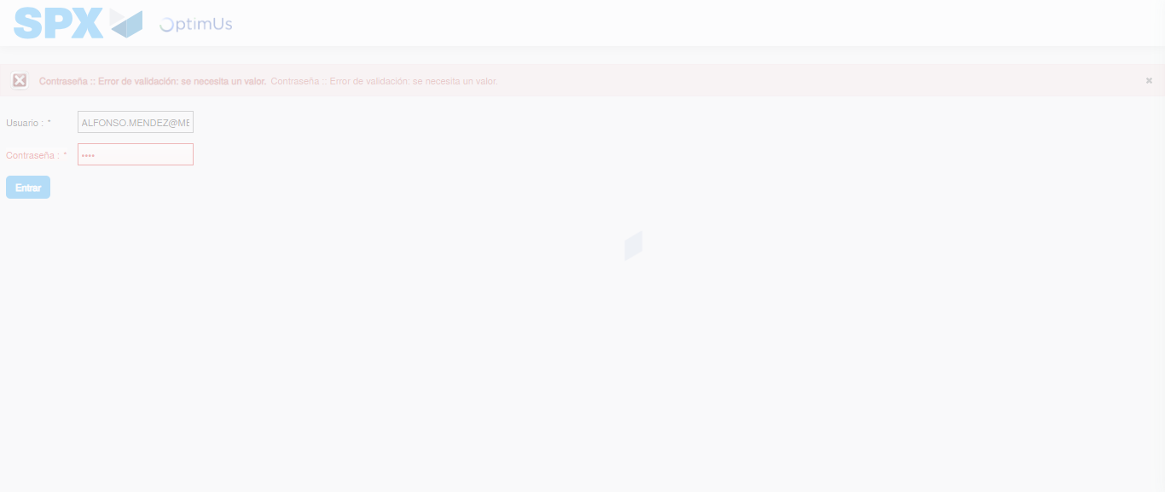Image file-name: QC_Testing-tc002_SPX_Dev5_Crear_Requisicion_Spot_Tipo_Cobro_Project-1784308039162

Step 2 - Select to UEN and Access to Spot Buy Requisitions : UEN Correctly selected and Correct access
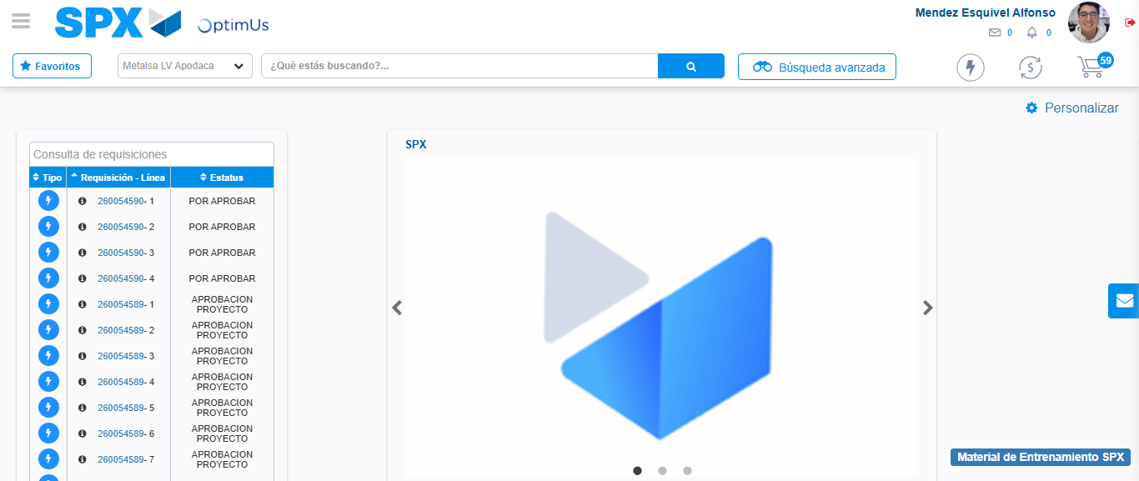Image file-name: QC_Testing-tc002_SPX_Dev5_Crear_Requisicion_Spot_Tipo_Cobro_Project-1784308070103

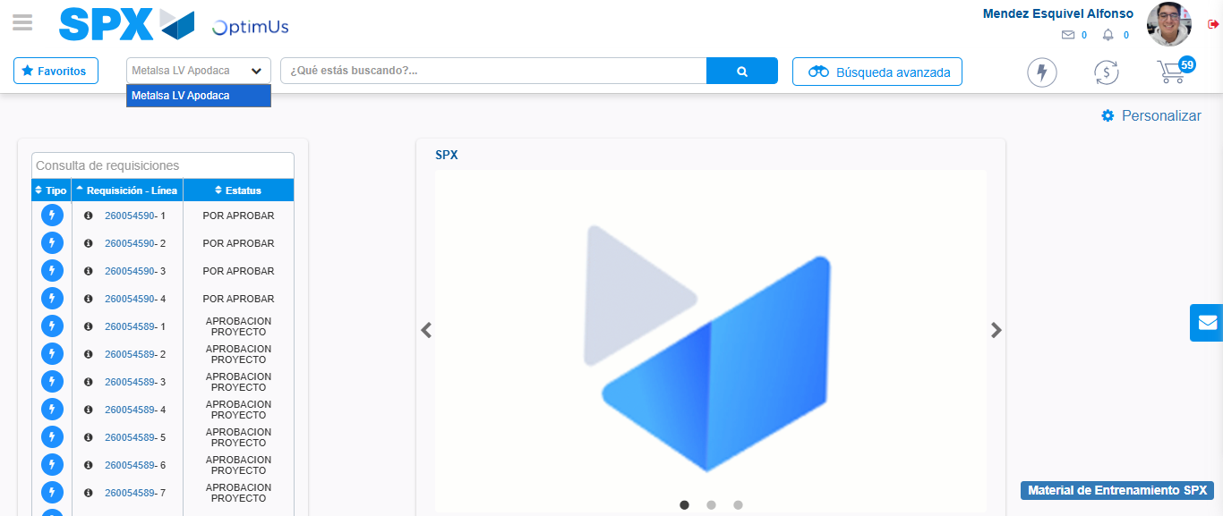Image file-name: QC_Testing-tc002_SPX_Dev5_Crear_Requisicion_Spot_Tipo_Cobro_Project-1784308072644

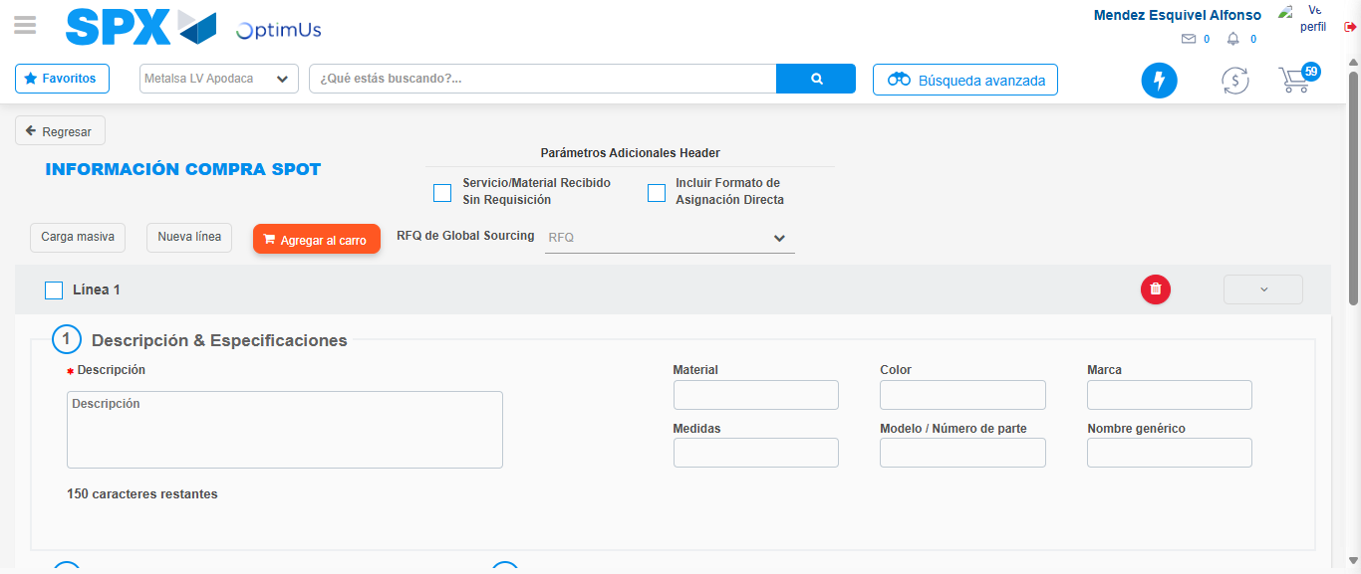Image file-name: QC_Testing-tc002_SPX_Dev5_Crear_Requisicion_Spot_Tipo_Cobro_Project-1784308090451

Step 3 - Data Capture Spot Buy Requisition: Data captured correctly
Image file-name: QC_Testing-tc002_SPX_Dev5_Crear_Requisicion_Spot_Tipo_Cobro_Project-1784308090683

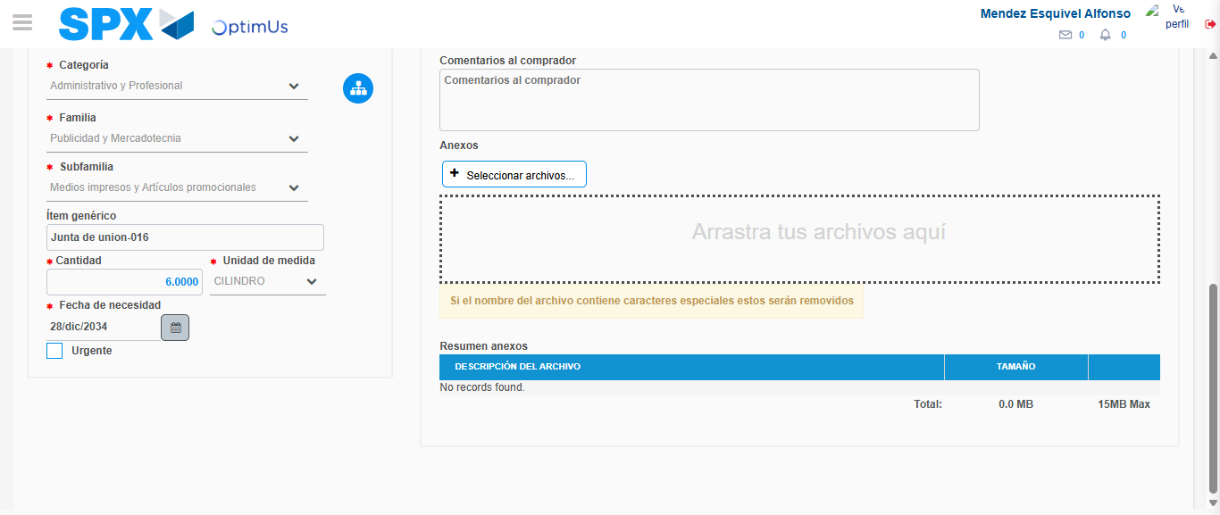Image file-name: QC_Testing-tc002_SPX_Dev5_Crear_Requisicion_Spot_Tipo_Cobro_Project-1784308101238

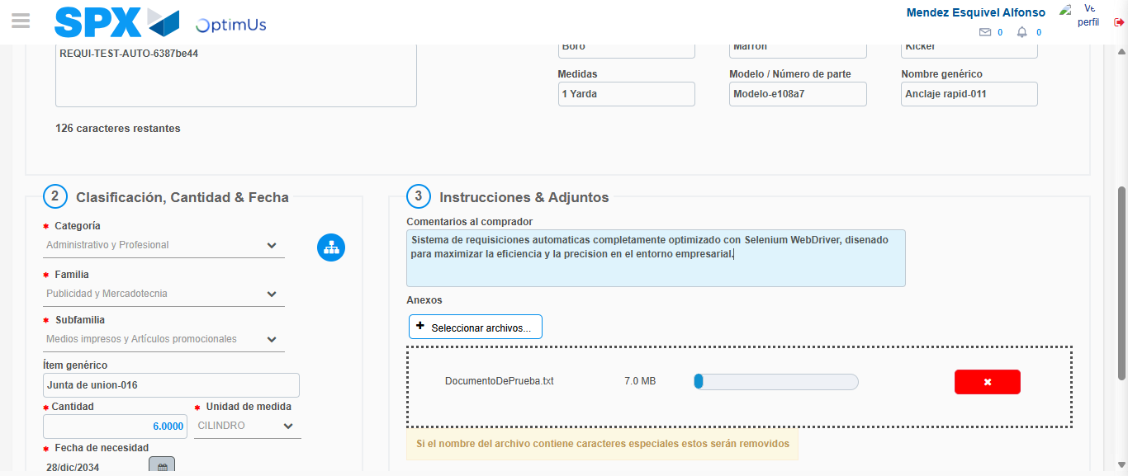Image file-name: QC_Testing-tc002_SPX_Dev5_Crear_Requisicion_Spot_Tipo_Cobro_Project-1784308101955

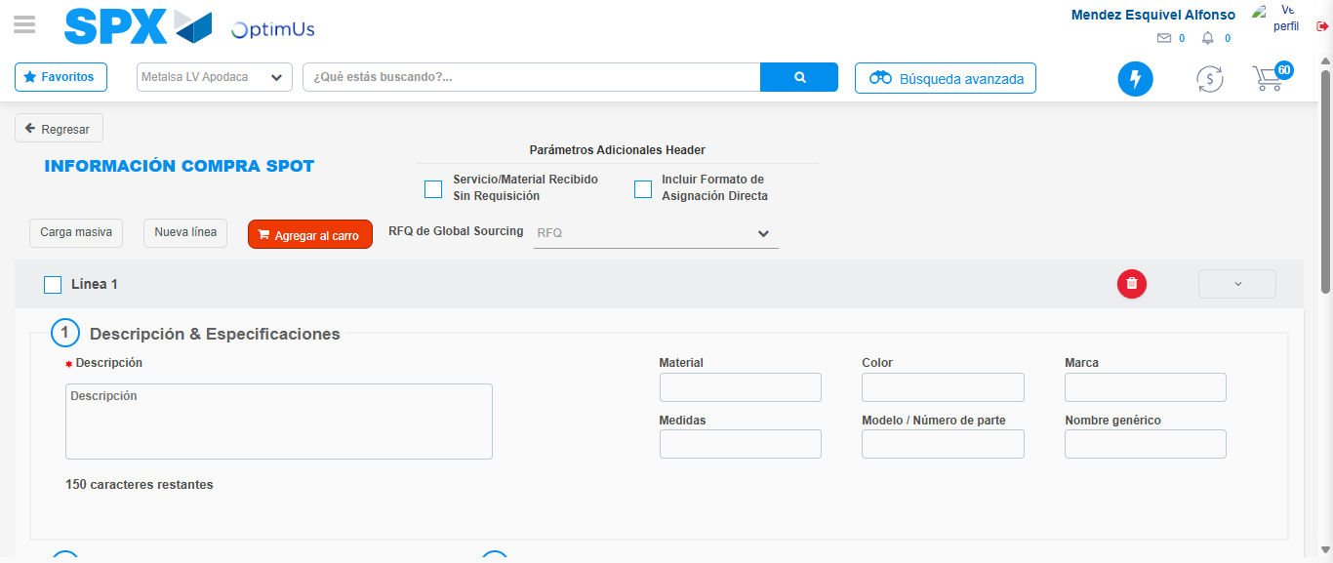Image file-name: QC_Testing-tc002_SPX_Dev5_Crear_Requisicion_Spot_Tipo_Cobro_Project-1784308109880

Step 7 - Return to Main Page SPX : Return to Main Page SPX
Image file-name: QC_Testing-tc002_SPX_Dev5_Crear_Requisicion_Spot_Tipo_Cobro_Project-1784308070103

Image file-name: QC_Testing-tc002_SPX_Dev5_Crear_Requisicion_Spot_Tipo_Cobro_Project-1784308072644

Image file-name: QC_Testing-tc002_SPX_Dev5_Crear_Requisicion_Spot_Tipo_Cobro_Project-1784308090451

Image file-name: QC_Testing-tc002_SPX_Dev5_Crear_Requisicion_Spot_Tipo_Cobro_Project-1784308112092

Image file-name: QC_Testing-tc002_SPX_Dev5_Crear_Requisicion_Spot_Tipo_Cobro_Project-1784308112244

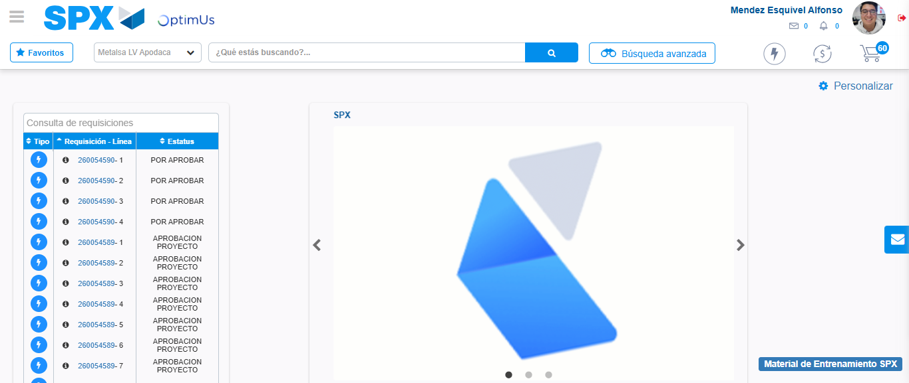Image file-name: QC_Testing-tc002_SPX_Dev5_Crear_Requisicion_Spot_Tipo_Cobro_Project-1784308133242

Step 8 - Log Out : Log Out SPX
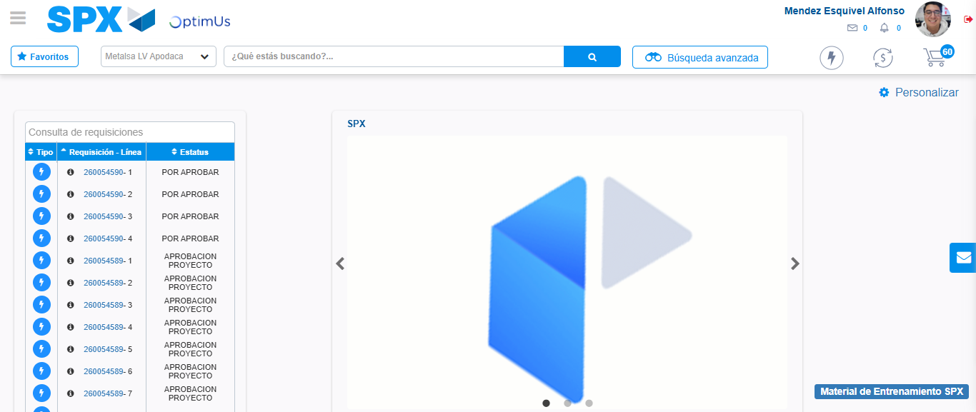Image file-name: QC_Testing-tc002_SPX_Dev5_Crear_Requisicion_Spot_Tipo_Cobro_Project-1784308133519

